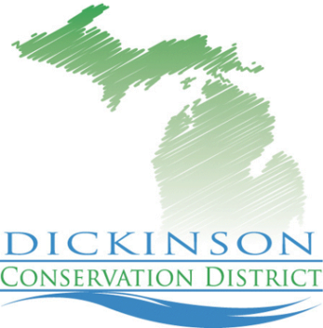

Fall Tree Sale

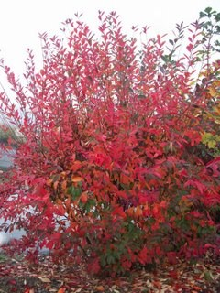
What Is Sold

- Fruit Trees
  - Apple
  - Plum
  - Pear
- Shrubs
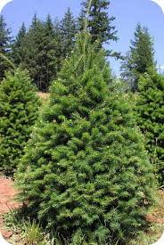
  - Winterberry
  - Red Chokecherry
  - Highbush Cranberry
- Conifers
  - Pines
  - Hemlock
  - Spruce

For more information contact
Ann Hruska- District Administrator/ Project Manager
420 North Hooper Street, Kingsford, MI 49802
Phone: 906-774-1550
Fax: 855-781-2330
E-mail: ann.hruska@mi.nacdnet.net Dates for tree sale not yet known

